MASS INTENTIONS & SERVICES FOR THE WEEK
Mon. 8:35AM Deceased of LoFago & Figorotta Family
R/B Frank & Lia
Tue. 8:35AM Owen McCarthy
R/B Patrick Zwiebel
8:35AM James Casey
R/B Zuccarello Family
8:35AM Frank Viola
R/B Lazarus Ministry
Wed. 8:35AM Alan Janosy
R/B Houle Family
Thu.. 8:35 AM William Donohue
R/B Family
Fri. 8:35AM Aunt Dorothy Toto (13A)
R/B Gabriella & Anthony Toto
Sat. 8:35AM Bernard Bahoshy
R/B Selwa & Albert Toni
. 4:45PM Michael Popper
R/B Downie Family
Sun. 7:15 AM People of the Parish
9:30AM Pasquale Berardi
R/B Connie & Carl Panzera
9::30AM Edward Barry
R/B Obenauer Family
9:30AM Dorothy & Dominick Nicoletti
R/B Carol & Ron Catera
11:30AM John Richard Peters
RB/ Gwen Peters & Dawn Bondar
6:00PM Loretta Witt
R/B WItt Family

READINGS FOR NEXT WEEK
2 Maccabees 7:1-2, 9-14 2 Thessalonians 2:16 – 3:5
Luke 20:27 - 38

NEW JERSEY INDEPENDENT
VICTIM COMPENSATION PROGRAM
The Diocese of Metuchen – along with the four other Roman Catholic Dioceses in New Jersey – established an Independent Victim Compensation Program (IVCP) to compensate those who, as children or young adults,
were sexually abused by a priest or deacon of the Diocese. The IVCP opened to claims on June 15 and will conclude on December 31, 2019. All individual claims must be submitted during this period.
The IVCP operates independently of the Diocese or any church-affiliated institution and the administrators
of the IVCP have complete autonomy to determine the eligibility of a claim with the guidelines of the established Protocol. The amount of compensation for those who make a claim will be independently determined by the IVCP administrators.
All victims – no matter when the abuse occurred – are eligible to participate, and all matters will be handled confidentially. Victims of clergy sexual abuse of a minor can begin the process of utilizing the program by going to www.njdiocesesivcp.com and reviewing the protocol for submitting a claim. Anyone who has been the victim of sexual abuse by a priest of the Diocese is encouraged to participate in the IVCP.
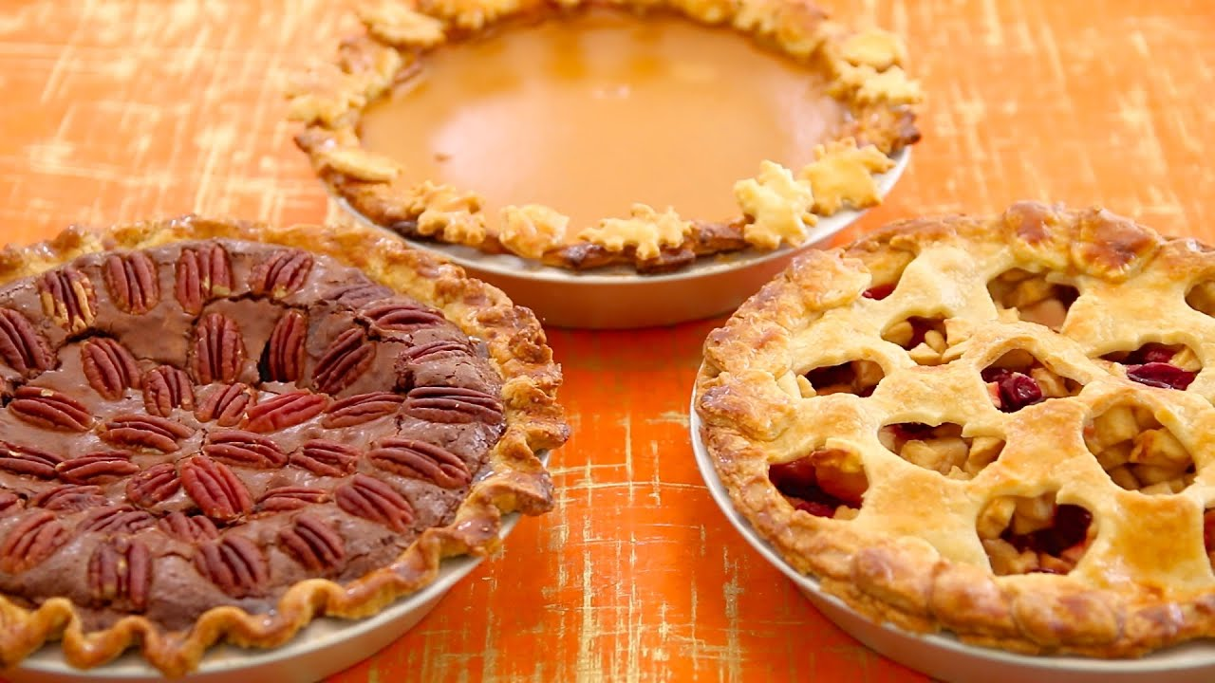

THE GUATEMALA MINISTRY
THANKSGIVING PIE SALE IS BACK:

On a First Come, First Serve Basis

Frozen Pies will be available for
Direct Purchase (No pre-ordering necessary)
in the Gathering Space
On Sunday, November 17, 8:AM-1:PM

Apple Pie: $17.00
Apple Crumb: $17.00
Pumpkin: $17.00
Chicken Pot Pie: $22.00

Please remember to bring Check or Cash!
All checks will be processed through our Diocese.

CHECKS SHOULD BE MADE OUT TO:
CATHOLIC CHARITIES with DIOCESE OF SANTA ROSA written on the Memo Line

Your Family’s Thanksgiving Traditions will help the extremely poor in Guatemala! St. Joseph’s Guatemala Ministry continues their 11-year effort of evangelization, solidarity, and bringing clean water to villages within the Parish of San Juan Tecuaco. This past year we purchased clean water filters for a school and continue to explore ways of bringing clean water to other villages. Annually, we sponsor a day at a pool, lunch included, for children and their chaperones, from the San Juan Parish: for many of these children, it is a once in a lifetime experience. We also purchased doors for a newly built chapel in a remote village within San Juan that previously had to celebrate Mass outdoors. St. Joe’s parishioner, Len Caliguari, travelled to Guatemala and constructed a beautiful Tabernacle for this new Chapel. Thank you, Len!! In the near future, we would like to purchase a Celebrant’s chair for the altar of this chapel.
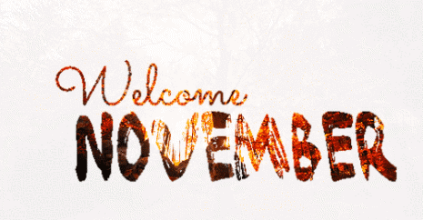
Around Our Parish
with Father Hank

Dear All: Christ’s Peace!.
LOOK FOR THE CONES! The new traffic pattern by the church’s main door took effect last week. Thanks for moving slowly around the parking lot and the neighborhood.

THIS WEEK IN PRAYER:
NOVEMBER REMEMBRANCES – Our “Scrolls of Remembrance” are installed.. In addition to the names presented on the scrolls, we will ask God to bless all the people whose names are written on the green Memorial Cards that will be on the main altar all month. You can continue to add names and submit cards all month.

THIS WEEK IN SERVICE:
THANKSGIVING FOOD BASKETS – As I continue to trip over the lawn furniture that still needs to be put away, I find it a little surprising that it is time for us to gear up for Thanksgiving. Our goal this year is to gather enough food to provide Thanksgiving dinners for 100 families (assuming the average family dinner will include 6-8 people). The collection runs from 11/9 through 11/22 at 3 pm. The food should be delivered in reusable shopping bags and placed in the Memorial Hallway. Our Youth Group will deliver the parcels on 11/23. If you are not able to purchase enough items for a full meal, consider donating a few of the items. Your donations will then be combined with others to make up baskets.

THIS WEEK IN COMMUNITY:
CALLING ALL VETERANS – We once again look forward to honoring all our veterans. The celebration – which takes place on Sunday, November 10 – begins with the 11:30 Mass and continues with lunch in the Parish Hall. Veterans are encouraged to bring a guest. The invitation also goes, most sincerely, to widows and widowers of veterans as well as to parents and spouses of active-duty service people.
CALLING ALL MARRIED COUPLES – SAVE THE DATE! Our parish celebration of marriage and married couples will occur on Saturday, February 8. It conflicts with nothing – not with Superbowl Sunday, not with Presidents’ Day weekend, not with Valentine’s Day and not with Groundhog Day – Plus it occurs before the start of Lent. You do not want to miss this one.
OUR STUDENTS’ ASPIRATIONS – Once again, thanks to all the students who let the parish know about your aspirations. It has been an invigorating and spiritually uplifting experience to learn of your hopes.!
OUR RECORDS UPDATE PROJECT, THE BASICS – You can pick up your packets this weekend/. Please be sure to bring an ID with you. It is best if you sign off on the needed corrections in the hospitality room. If that is not feasible and you take your envelope home, please return your packets in the green and grey bins. Thank you for your patience with this process.
OUR RECORDS UPDATE PROJECT, A LARGER VIEW – I missed the very first round of records distribution, the one that occurred after the 4:45 Mass on Saturday. As I mentioned on Sunday, I was at my nephew’s wedding, and missing you, and loving my nephew, Peter, his wife, Gina, and their completely wonderful celebration. Of course, I was here for all the Masses on Sunday and was able to take in the remarkable news that the records project supplies. The Hospitality Room activity consoled me in many ways. Three of them merit mention.
First, the good folks on our parish council and its planning committee are terrific people who have been blessed with great insight and tremendous generosity of spirit. Their commitment to improving our parish records, simply so that we can discern more carefully how God is nudging our parish and its members, is a wonder to behold.
Second, the people who planned the project and those who agreed to help implement it, are wonderful and talented humans. Again, their dedication to parish and generous spirits glorify God.
Third, the parishioners who retrieved and corrected their records demonstrated great kindness, humor, and an underlying commitment to the parish.

That experience, like so many others that you provide, reminded me anew that being here with you makes me feel like the luckiest guy I know.
With all best blessings,
Fr. Hank

Father Hank’s homilies are just a click away! Sunday’s homily will be posted on Monday. Check it out on www.stjosephsparish.com

IN MEMORIAM
Darlene P. Mecca, 72, died on October 18.
Please pray for her eternal rest and for consolation for her family and for all who mourn her death.
ST. JOSEPH SAGES PRESENT:

November 4, Monday-Funday:
Lunch, Movie & Poker game
11:30 AM Parish Hall
The movie is On the Basis of Sex which tells an inspiring story that follows young lawyer Ruth Bader Ginsburg as she teams with her husband to bring a groundbreaking case before the Supreme Court and overturn a century of gender discrimination.

November 18, Monday Funday: Lunch,
UKULELE SHOW & Poker game 11:30 AM Parish Hall

Chair Exercises are every Thursday at 11 AM

Dance Class on Thursdays, 12 PM until December 12.

MARK YOUR CALENDAR:
SAGES Holiday Luncheon & Variety Show
Monday, December 16, 11:30 AM.

See SAGES Bulletin Board for details and sign-up

WHO ARE THE COLUMBIETTES?
And what do they do? and how do I join?
The Columbiettes is an organization of Catholic women, 18 years of age or older, who are affiliated with the Knights of Columbus.
As a charitable, not-for-profit organization, we support many different charities and are involved in community activities as well as working collectively with our Brother Knights to promote faith and unity. We also have many social events, as well as our religious and charitable works where you will have the opportunity to meet other women who share your interest. We are an organization of women from all backgrounds united by our Catholic faith, the Love of our family, our Love of Country and our commitment to helping others.
There is going to be a degree ceremony held on
November 17th at 2PMn Union NJ where you can officially become a member of this wonderful organization.
If you are interested in becoming a Millstone Valley Columbiette please contact our Vice President, Erica Ruffer at (908) 432-4340 or thebove528@hotmail.com.
Get in the Spirit

HOLIDAY SPIRIT
SHOPPING FAIR

Wednesday November 20

Doors open at 6:00PM

Gathering Space of the Church

The Millstone Valley Columbiettes
invite you
to join us for an evening of fellowship, fun, crafts, refreshments and much, much more!
It's a perfect opportunity
to do some holiday shopping
while supporting local crafters & vendors.
Free Refreshments.

There is no charge for admission
and ALL are welcome

By joining us as this event you
will support the charitable works of
the Millstone Valley Columbiettes!!

VETERANS DAY CELEBRATION MASS
Please join us as we honor
the Veterans of our parish.
Sunday, November 10 at the 11:30 AM Mass.

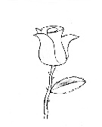WELCOME to the
This Photo by Unknown Author is licensed under CC BY
CULTURE of LIFE CORNER

The mission of the Respect Life ministry is “to raise awareness of all threats to the sanctity of life, especially to the unborn, to the aged, and to the infirm.”
A 2012 study, published in the journal of Prenatal Diagnosis, found abortion rates were over 90% in cases where families were given the news that the babies had Down syndrome. This is in direct opposition to the belief that all life is sacred. There is help for those who choose not to terminate pregnancy in situations of an unexpected prenatal diagnosis. The diocese of Metuchen website (https://diometuchen.org/assets/Uploads/Documents/RespectforLife/poorprenatal2card.pdf) provides a listing of resources ranging from birth plans to community based support throughout pregnancy and after delivery.
Are there other issues or resources you want to learn about from the Respect Life ministry? Please feel free to reach out to Rachelle at rachelle.hanna@gmail.com with any suggestions.

MARRIAGE ENCOUNTER
Now that fall is here, why not treat yourselves to a Marriage Encounter Weekend? A Worldwide Marriage Encounter Weekend gives you the time and tools to revitalize romance, deepen communication, and nourish the spirituality in your marriage.
The next Worldwide Marriage Encounter Weekend will be held January 24 - 26.
Please register by January 10, as space is limited.
Phone 1-732-904-9636 for registration and information.
Visit us at: www.aweekendforyourmarriage.org for more information.

ANNULMENT INFORMATION
An Information Session on Annulments
will be held at Blessed Sacrament Church
1890 Washington Valley Road in Martinsville
on Wednesday, November 13, 2019
AND
Saint Elizabeth Ann Seton Church
105 Summer Road in Three Bridges
(GPS: use Flemington)
on Thursday, November 14, 2019.
Both identical presentations will begin at 7:30 PM.
These identical presentations are intended for those who have experienced the pain and anguish of a divorce and who wish to learn more about the Annulment process and have common myths dispelled.

IN GOD’S IMAGE
In God's Image, the Catholic Faith Sharing Group for gay, lesbian, bisexual and transgender people at Sacred Heart Church, South Plainfield, meets the 2nd Wednesday of every month at 7:00PM.
On November 13 we will meet in the church when we will have a guest speaker who helped to originate the Broadway play Come From Away.
The group is open to LGBT adults, 18 and over, and their families. All are welcome for faith sharing, prayer, conversation and support. For more information, contact Fr John at 908 756 0633, ext 125 or the group may be reached by contacting 908 822 5895 or by emailing sacredheartigi@gmail.com

WEEKLY CALENDAR
Sunday, November 3
8:15AM CCD Class CR3
10:30AM Ministry Meeting N
10:45AM CCD PC
1:30PM FPU PH
7PM Blue Storm Board Mtg. CR1
Monday, November 4
11:30AM SAGES Monday-Funday PH
6:PM Becca’s Friends Planning Mtg. HR
7PM WWP PH
Tuesday, November 5
9AM Faith Sharing HR
9:15AM WWP PH
10:30AM SAGES Writing Class HR
7PM Buildings & Grounds HR
Wednesday, November 6
9AM First Weds. & Birthday Breakfast HR
10AM Sages Health Workshop N
7PM RCIA CR1
7:30PM Columbiettes HR
Thursday, November 7
11AM Sages Chair Exercise PH
7PM Blue Storm Coaches Mtg. C
7:45PM Choir Practice MR/C
Friday, November 8
10AM SAGES Health Workshop N
8PM AA HR
Saturday, November 9

(C) Church; (PH) Parish Hall; (HR) Hospitality Room; (MR) Music Room; (YMR) Youth Ministry Room; (PFO) Parish Front Office;(PC) Parish Center; (PG) Parish Grounds; (N) Nursery. Chap (Chapel)

BULLETIN DEADLINE
Please send info for the bulletin no later than Thursday, 9 days prior to the weekend you want the article to appear, directly to stjoebulletin@yahoo.com. Full page announcements must be submitted at least 3 weeks in advance and although we try our best, they are subject to space restrictions. Contact Dorothy at
.stjoebulletin@yahoo.com. Thank You.

.

